**Lab 5**

**Deliverable 1 → Map Product**

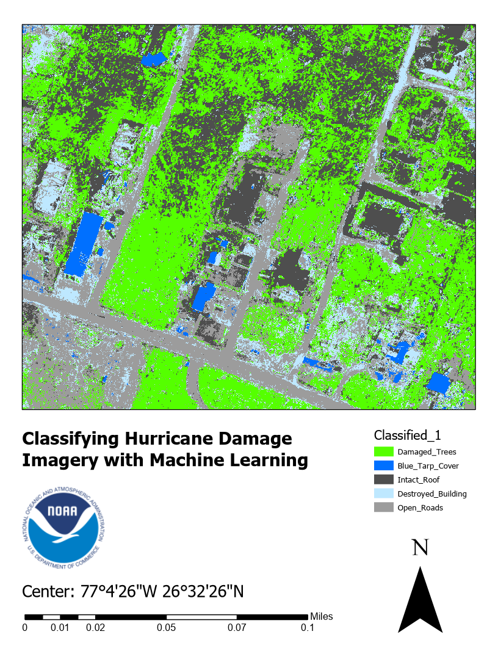

**Deliverable 2 → Confusion Matrix**

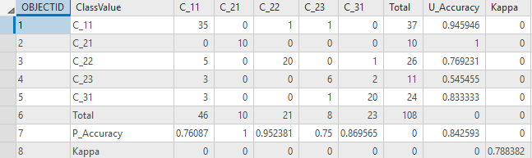

In the table above we can see that C_21 (Blue Tarp Cover is the class that has received U_Accuracy and P_Accuracy of 1 indicating complete agreement. There were some misinterpretations for the C_23(Destroyed Buildings), C_22(Intact Roof) and C_31(Open Roads) classes mainly because of the grayish color similarity. Some false negatives too were observed in case of C11(Trees) with failure in identifying trees correctly and assuming them to be C_22, C_23 or C_31 thus reducing the P_Accuracy (~76). The kappa value of ~79 would be considered “substantial agreement” according to the “Almost Perfect Agreement”. Hence, the algorithm results suggest that the classification results fair moderately well seeing the requirement mentioned in the agreement.

**Deliverable 3 → Answers to Discussion Questions**

**Question 1 →** *What other classification classes might you have included as per the schema that was loaded In task 3 step one? For example, open grass? Also, look at the bigger image that the image used in this exercise was derived from and provided with the exercise datasets. What other types of classification classes might you find from that bigger image and how might that inform the use of classification algorithms to support a disaster response?*

**Answer →** Cars, Yards, Porch, Debris. Such data can be used to identify areas where people may be trapped thus helping create a strategy for the same in advance. In addition to this, it will avoid the risk of life for sending search teams in areas where it won’t be required or as a matter of fact help prioritize regions to be searched.

**Question 2 →** *The overall accuracy of the classification based on the Kappa value discussed in Task 6 was “substantial agreement” between ground truth data and machine data. Although this was good, it was by no means perfect. How might these types of errors potentially produce problems when using the outputs of this analysis for Disaster Response? For example, if developing damage assessment maps based on machine learning algorithm outputs, what problems might occur with use of these maps in terms of inaccuracy?*

**Answer →** Although the agreement states that it is good, in case of disaster response analysis it can lead to problems like not targeting the correct areas and eventually resulting in loss of life because of thinking that the analysis provides enough evidence of where to look for in order. At the same time we should not forget that these results can be of a lot of help too until they are not relied on to completely and used with caution especially in the case of disaster management.